WebEx Files Import/Upload Workflows and Enablement

Version: Hercules



**Kaltura Business Headquarters**

5 Union Square West, Suite 602, New York, NY, 10003, USA

Tel.: +1 800 871 5224



Copyright © 2013 Kaltura Inc. All Rights Reserved. Designated trademarks and brands are the property of their respective owners.

Use of this document constitutes acceptance of the Kaltura Terms of Use and Privacy Policy.

# Contents

Workflow 1 – KMC - Upload Multiple ARF files from desktop 4

Workflow 2 – KMC - Import a Single ARF File from Webex Server 4

Workflow 3 – KMC - Bulk Upload Multiple ARF Files 6

Workflow 4 – KMC - Upload Single ARF File using Aspera 6

Workflow 5 – KMC - Upload Multiple ARF Files Using Drop-folders 6

Workflow 6 – KMS - Upload a Single ARF File from Desktop 6

Workflow 7 – Applications - Upload a Single ARF File from desktop 7

Created Flavors 7

Limitations 7

How to Enable ARF Upload from KMS 8

KMS KSU 8

How to Enable ARF Upload from Other Applications 9

Default UI Confs 9

# Kaltura’s Support for Ingestion of the Webex ARF File Format

This article describes and presents information about Kaltura’s support for ingestion of the Webex ARF file format and provides supported workflows for various Kaltura applications. Information about the created flavors is provided as well as a way to enable support for non-supported apps.

Information for the following workflows is provided:

Workflow 1 – KMC - Upload Multiple ARF files from desktop

Workflow 2 – KMC - Import a Single ARF File from Webex Server

Workflow 3 – KMC - Bulk Upload Multiple ARF Files

Workflow 4 – KMC - Upload Single ARF File using Aspera

Workflow 5 – KMC - Upload Multiple ARF Files Using Drop-folders

Workflow 6 – KMS - Upload a Single ARF File from Desktop

Workflow 7 – Applications - Upload a Single ARF File from desktop

## Workflow 1 – KMC - Upload Multiple ARF Files from Desktop

1. In the KMC Upload tab, select Upload from desktop.
2. Browse to your file.

The KMC uploader supports uploading single or multiple ARF files.

## Workflow 2 – KMC - Import a Single ARF File from Webex Server

1. Copy the link in the “Download recording link” from the Webex server:

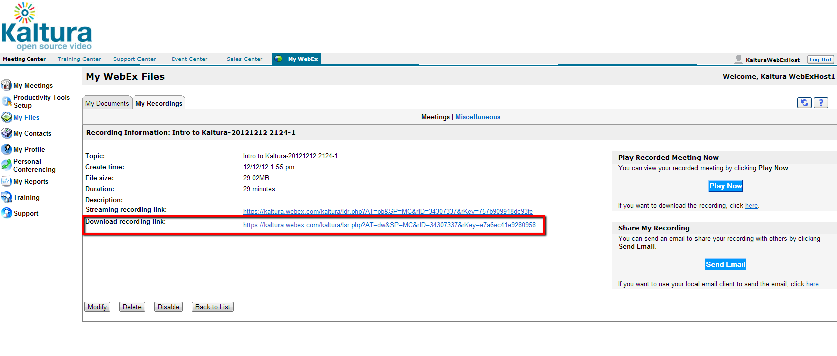

1. Create a media-less entry in the KMC. Select the Upload tab and then select Prepare Video Entry.

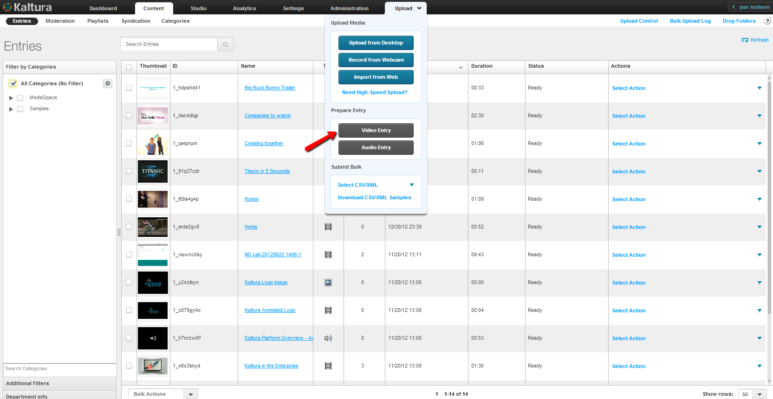

1. In the New Entry window select the Flavors tab.

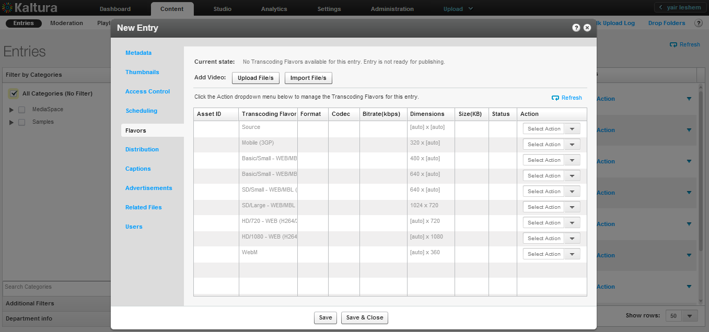

1. Select Import File/s.

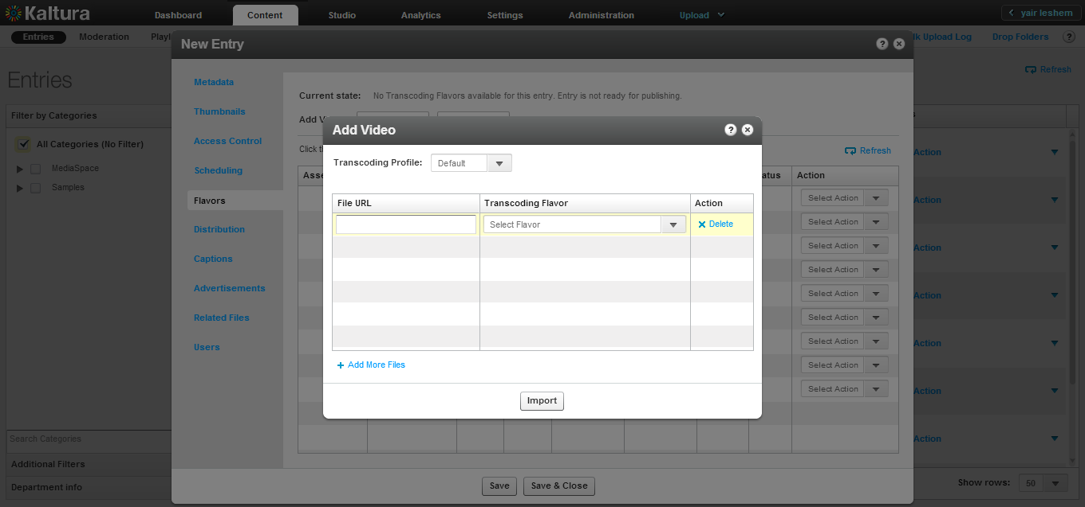

1. Paste the URL that you copied from the “Download recording link” from the Webex server and click Import.

After the file is imported and transcoding is done, the entry is ready.

## Workflow 3 – KMC - Bulk Upload Multiple ARF Files

1. In the KMC Upload tab, select Submit Bulk and then select CSV/XML.
2. In the CSV/XML file , insert the URL pointing to the ARF file. The URL may be that you copied from the “Download recording link” from the Webex server or from another location.
3. Upload the CSV file as you would in the regular KMC workflow.

## Workflow 4 – KMC - Upload a Single ARF File using Aspera

The regular KMC Aspera workflow supports ARF files.

## Workflow 5 – KMC - Upload Multiple ARF Files Using Drop-folders

The regular KMC Drop-folders workflow supports ARF files.

## Workflow 6 – KMS - Upload a Single ARF File from Desktop

1. In the Add New tab choose Media Upload.
2. Browse to your file and add media. ARF files. (Only single files are supported.)
3. The MediaSpace flow continues normally.

This feature is included by default to new customers running on SaaS KMS 4.6. Existing customers running on SaaS KMS 4.6 will need to request that this feature be enabled for them . See How to Enable ARF Upload from KMS.

When the SaaS KMS 5 is released, this feature will be available to all customers running KMS5.

## Workflow 7 – Applications - Upload a Single ARF File from desktop

* Upload a single file using the KCW in the application.

The feature is available for the KCW default version in the various Kaltura applications (Blackboard, Sakai, Moodle, Wordpress, Drupal). For non-default KCW versions, this feature may be added, per request.

## Created Flavors

The entry will include:

1. The original ARF file – the file can playback on the Webex player and saved for future use. The file does not have to be hosted on the Webex server as well.
2. A Kaltura source file – WMV format, from which the customer can re-transcode to any flavor.
3. All the customer’s flavors.

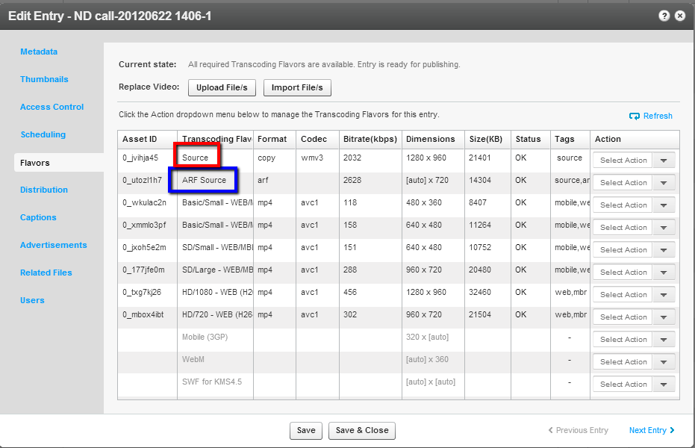

## Limitations

When ingesting from WebEx, only the presentation panel is included in Kaltura’s panel. Other panels such as polling, Video, Chat or file transfer may be available at a later date.

## How to Enable ARF Upload from KMS

### KMS KSU

In KMS 4.6, for new customers, ARF Upload will be enabled. Existing customers will need to update the UIConf with *.ARF. In KMS 5.0 this feature is included.

* To update UIConf with *.ARF

1. In the Kaltura Admin Console, select the UI Confs Management tab.
2. Select the relevant partner ID.
3. Open the MediaSpace video upload widget (ksuID)

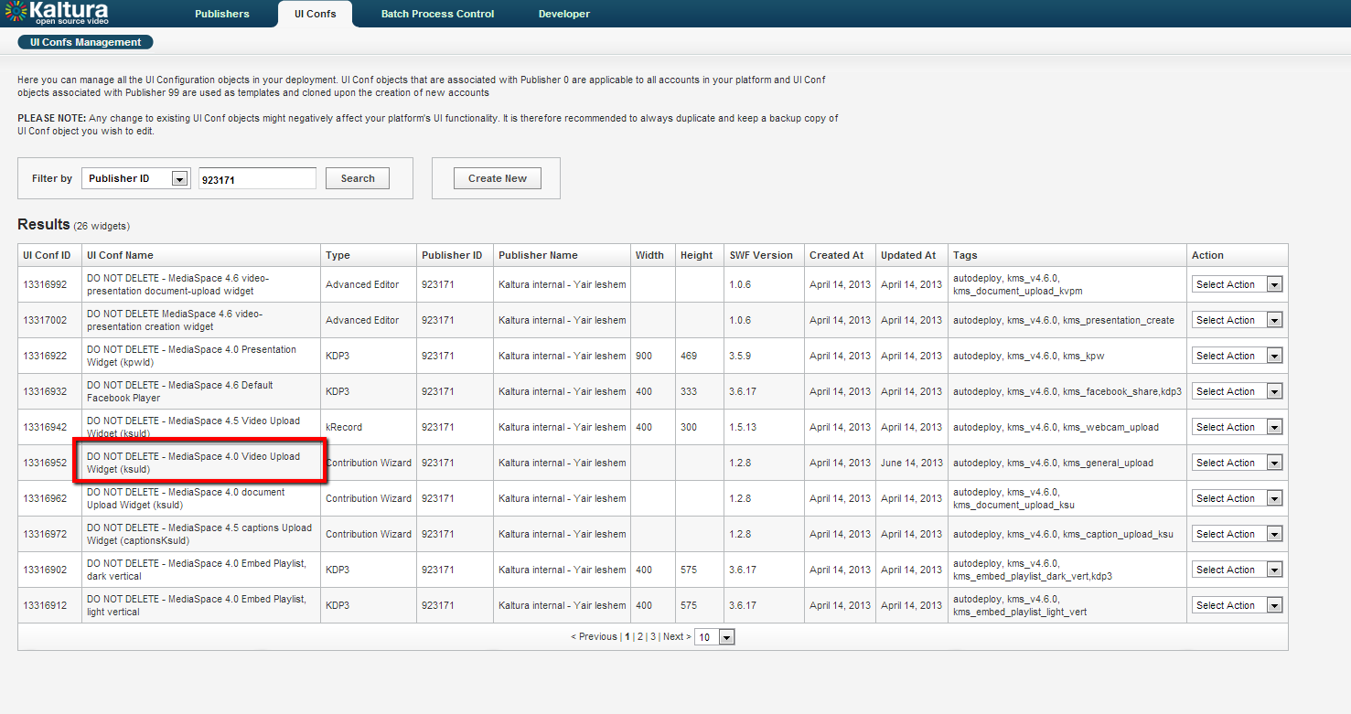

1. Select Edit UI Conf and Open the editor.
2. Add *.arf and *.ARF to the extensions list in both fileFilter id="video" and fileFilter id="media"

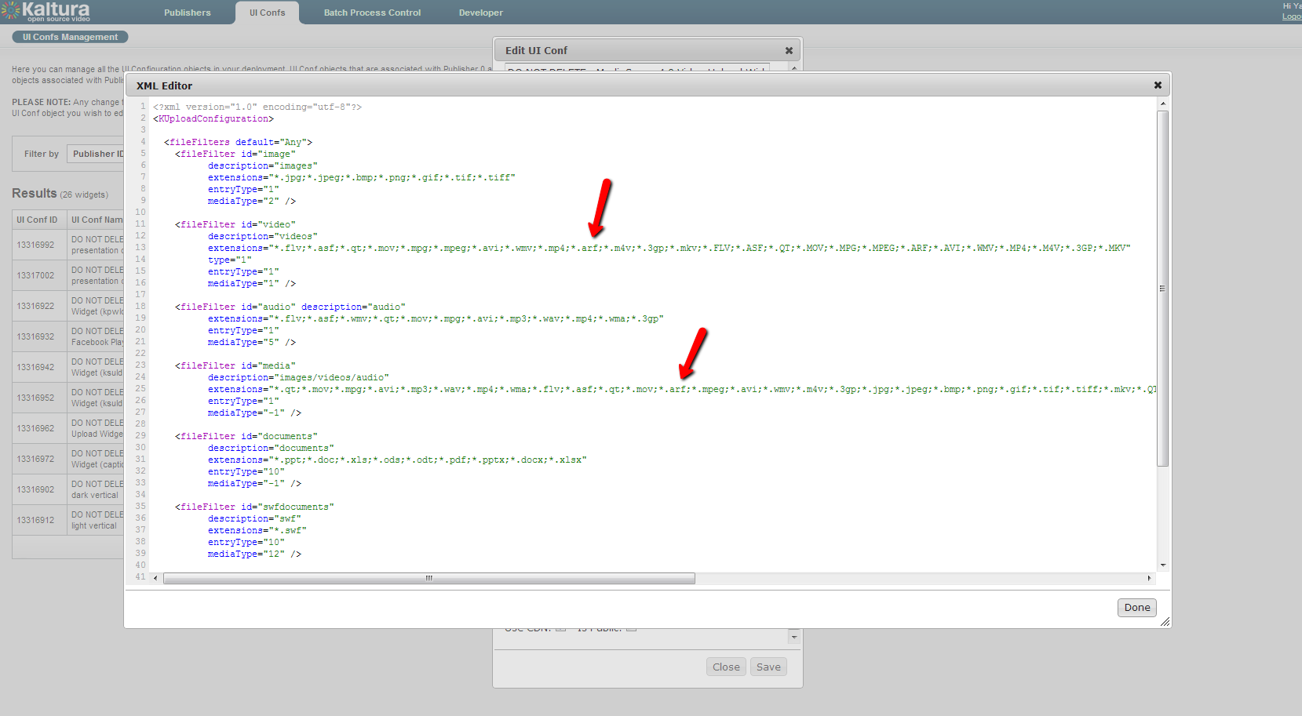

1. Click Done and then Save.

## How to Enable ARF Upload from Other Applications

* Apps KCW – the default KCW will be enabled with *.ARF (see Default UI Confs).
* For non-default UIConfs, you will need to update them with .ARF. In Blackboard for example - same idea as in KMS: Go to Admin Console and edit the current UIConf (KCW my media).

### Default UI Confs

The following UI Confs, which are the default UI Confs of these apps, are enabled with ARF support. Therefore, the ARF extension is allowed in "upload video" tab.

* Sakai KCW – 11601051
* Moodle KCW – 6709401
* Blackboard course gallery KCW – 6235211
* Blackboard my-media KCW – 6235221
* Drupal all-media KCW – 4396241
* Drupal video-only KCW – 4396041
* Wordpress KCW – 542
* Wordpress admin KCW – 543
* Wordpress comments KCW – 544
* Wordpress KCW for simple-editor - 541